**Truth Baptist Church**

**60 Burnham Street, South Windsor, CT 06074**

**(860) 289-8976**

[TruthBaptistChurch.org](mailto:TruthBaptistChurch.org) info@TruthBaptistChurch.org

Bim Rowley – Co-Pastor

Matt Harper – Co-Pastor

Keith Tower – Executive Pastor

Eli Rodriguez – Youth Pastor

Our core values involve **Connecting** with other believers, **Growing** in our relationship with Jesus, and **Thriving** in every area of life.

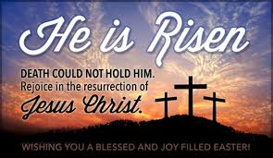

**Schedule for Today**

**9:00 a.m. Bible Memory**

**9:15 a.m. Sunday School & ABF**

**10:30 a.m. Morning Service**

**5:45 p.m. Kids Sing Truth**

**6:00 p.m. Evening Service**

**Schedule for the Week**

**Wednesday Life Groups**

**Save the Dates**

**Teen Outreach at the Hartford Project – May 4**

**VBS – July 8-12**

**Teen Camp at The Wilds – July 22-27**

**Camp-out in the church field – Aug. 23-24**

**Harvest Banquet & Special Services – Nov. 9-13**

**Upcoming Events**

**Contact the church at** [**info@TruthBaptistChurch.org**](mailto:info@TruthBaptistChurch.org) **for info on any of these events. More information can be found at TruthBaptistChurch.org**

**Today – 10:30 a.m., Back to Basics: The Foundation Stones of Faith**

Just like the structural foundation is the most important part of any building, so our spiritual foundation is the most important part of our lives. Join us Easter morning as we start a new series of messages about Biblical truths, including salvation, baptism, communion, eternal security and giving.

**Sunday, April 28 – 6:00 p.m., Daniel Elmer preaching**

Daniel Elmer is a missionary to South Africa. He will be preaching and presenting their ministry.

**Sunday, April 28 – 7:15 p.m., April Fellowship**

**Easter Basket Donations**

If you have donations for the Easter Basket for the South Windsor Police Department, they can be placed in the marked basket in the lobby this morning.

**Special Thanks**

Dear TBC Ladies,

Thank you for the surprise at the Ladies Tea! Thank you for sharing many memories with me over the years, taking the time to contact many friends from the past, preparing the delicious food, the Amazon gift card, and the “tea” decorations! I am humbled to think the Lord has given me so many wonderful friends like YOU!

Deanna Rowley

**Church Phone List**

There are copies of the church phone list at the welcome desk. Please email additions and changes to your contact info to info@TruthBaptistChurch.org.

**Prayer Requests**

Please send prayer requests to [truthchurchprayer@gmail.com](mailto:truthchurchprayer@gmail.com)

**The mission of TBC is to glorify God by reaching and training reproducing disciples of Jesus Christ.**

**Weekly Report**

**4/14/2019**

Attendance

Sunday School 128

Morning Service 193

Evening Service 143

Friday 146

Offering $11,737.10

**Deacons**

Elvis Chidozie, John Dannecker, Steve Greenwood, Adam Ploszaj,

Ed St. Pierre, Kevin Tower

**Missionaries**

Beaman (Zambia) Hudson (Austria)

Bollon (Taiwan) Hutchins (Northeast Asia)

Brackett (Argentina) Keller (Ukraine)

Burrills (Malta) Olson (Toronto)

Cerna (El Salvador) Parry (Hispanics)

Cherian (India) Patton (Suriname)

Conrad (Hong Kong) Smith (Asia)

Fairchild (Indonesia) Stertz (Couriers for Christ)

Hoover (Ethiopia) Tuttle (Georgia)

The Cernas (El Salvador) report that they were recently able to baptize Ricardo Saiguero who is 20 years old. He has been coming to church for five years. He did make a profession of faith, but was reluctant to grow in his spiritual life until recently. God has used several trials in his life to create a desire to learn more about God. Mauricio (the other pastor) has been teaching him God’s Word through the discipleship course. Both Mauricio and his father Jose’ have been church members for a number of years and both are beginning to disciple others. Please pray that the Lord will continue to open doors. The future of the church truly does depend on men like these serving in the local church.



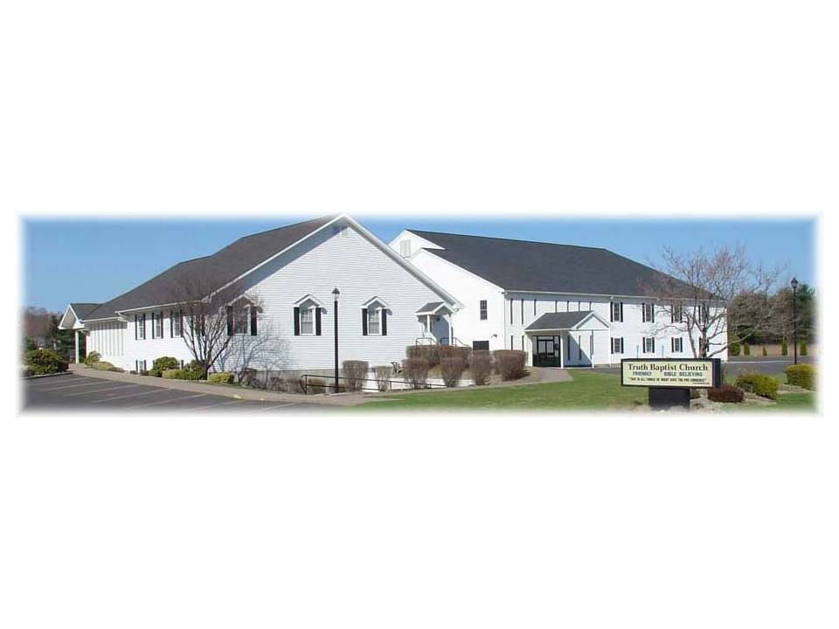**That in all things He might have the preeminence.**

**Colossians 1:18**

**April 21, 2019**