Truth Baptist Church
60 Burnham Street, South Windsor, CT 06074
(860) 289-8976
TruthBaptistChurch.org info@TruthBaptistChurch.org
Bim Rowley – Co-Pastor
Matt Harper – Co-Pastor
Keith Tower – Executive Pastor
Eli Rodriguez – Youth Pastor

Our core values involve Connecting with other believers, Growing in our relationship with Jesus, and Thriving in every area of life.
Schedule for Today
9:00 a.m. Bible Memory
9:15 a.m. Sunday School & ABF
10:30 a.m. Morning Service
5:45 p.m. Kids Sing Truth
6:00 p.m. Evening Service
Schedule for the Week
Wednesday Life Groups

Save the Dates
VBS – July 8-12

Truth Basketball League
TBL has started, but it’s not too late to join in! Register online. Postcard fliers are in the lobby to use for inviting friends.
Men’s Meeting
There will be no men’s meeting in February.
Membership
We will be voting on Ajitha James for membership tonight.
Thank You
There is a “Thank You” note from the Hanovers to our church available to read at the Welcome Center in the lobby.

The mission of TBC is to glorify God by reaching and training reproducing disciples of Jesus Christ.
Upcoming Events
Contact the church at info@TruthBaptistChurch.org for info on any of these events. More information can be found at TruthBaptistChurch.org.

Tonight – 6:00 p.m., “Works of God Night”
Plan to come to an open mic night for testimonies of what God has done to show Himself real in our lives.

Tonight – 7:15 p.m., Teen Afterglow
Teens are invited to an Afterglow at the Rodriguez’s home right after the evening service. Come for a time of fellowship, food, and spiritual growth! The bus will leave TBC at 7:15 p.m. Teens can be picked up at 9:00 from the Rodriguez home, or 9:30 at TBC. See Pastor Eli for more information.

Saturday, February 16 – 6:00 p.m., Bridal Shower for Charlotte Toal
All ladies are invited to Charlotte’s (Jonathan Barisano) bridal shower. Please sign up at the coffee station.

Saturday, February 23 – 11:15 a.m., Teen Ski Trip
The teens are going to Bousquet to ski and we are inviting others to join us! The cost is $45 (plus bring your own bag lunch/money for food). We will meet at TBC at 11:15 a.m. (leaving right after basketball). We will return at 8:30 p.m. See Pastor Eli if you are interested in coming along.

Weekly Report

2/3/2019
Attendance
Sunday School 111
Morning Service 234
Evening Service 107
Offering $8,159.62

Deacons
Elvis Chidozie, John Dannecker, Steve Greenwood, Adam Ploszaj,
Ed St. Pierre, Kevin Tower

Missionaries
Beaman (Zambia) Hudson (Austria)
Bollon (Taiwan) Hutchins (Northeast Asia)
Brackett (Argentina) Keller (Ukraine)
Burrills (Malta) Olson (Toronto)
Cerna (El Salvador) Parry (Hispanics)
Cherian (India) Patton (Suriname)
Conrad (Hong Kong) Smith (Asia)
Fairchild (Indonesia) Stertz (Couriers for Christ)
Hoover (Ethiopia) Tuttle (Georgia)

The Burrills (Malta) report that 2018 was a very exciting year for them. In January, Josh’s parents visited them for six weeks. They were able to celebrate Naya’s sixth birthday with her in Malta. The winter months were filled with ministry and life responsibilities. Pastor Joe and Jenny returned from furlough and were able to work alongside of them in many areas of the ministry. Pastor Joe and Josh share the preaching and coordinate the schedules for the year. The church building project continues and they hope to have the elevator installed soon. Erica was able to teach a Ladies Bible/Book Study earlier in the year. The group meets weekly and about 20 ladies are attending. Erica is also involved with the children’s ministry. One of the young men in the church has recently started a Facebook page for the young adults. Erica’s parents visited for a month in October and brought many gifts for them from Canada.



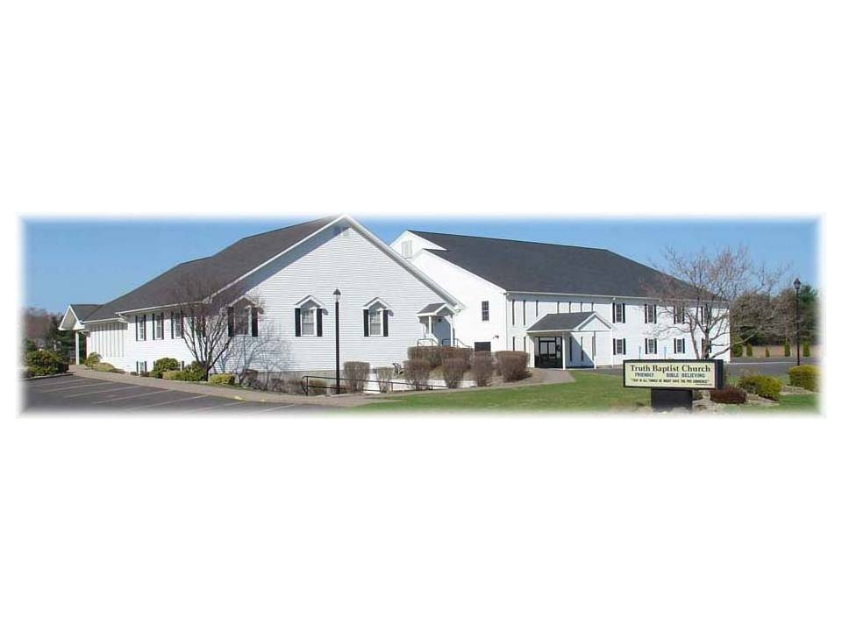
That in all things He might have the preeminence.
Colossians 1:18

February 10, 2019

