Blessed be the God and Father of our Lord Jesus Christ, the Father of mercies and God of all comfort, who comforts us in all our tribulation, that we may be able to comfort those who are in any trouble.

2 Corinthians 1:3&4

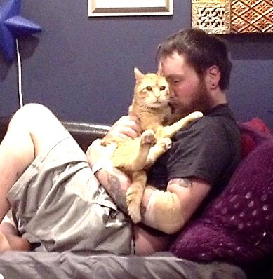

Finn welcoming Paul home from Bridgeport Burn Unit in May 2015.

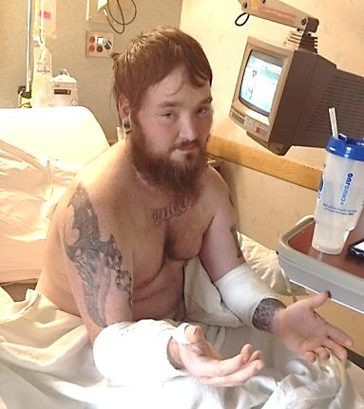Paul in Hartford Hospital for second surgery in July 2015.

**Remembering…**

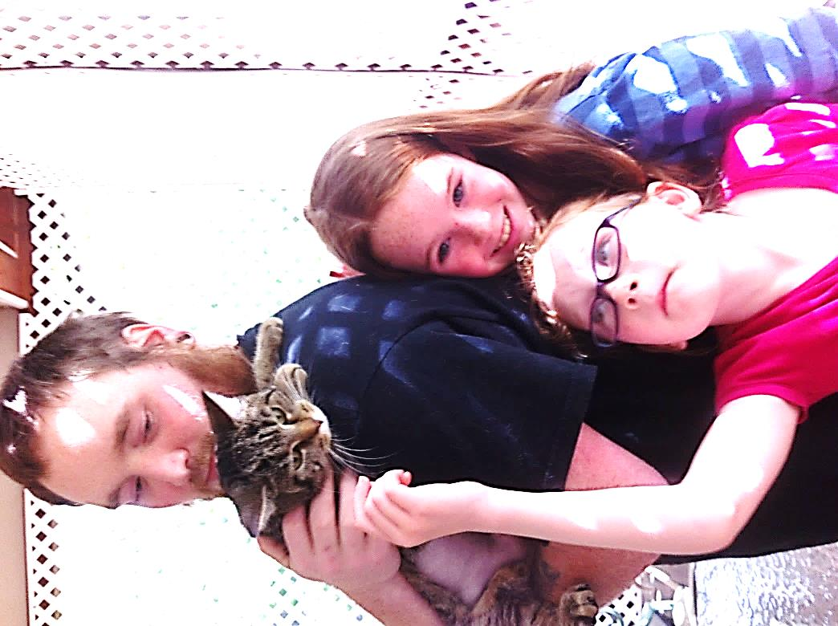

***Welcome home, Willow!***

**Paul Daniel Sullivan**

**June 7, 1983 – June 25, 2016**

***Paul grew up in Newington and attended and graduated from Emmanuel Christian Academy. He loved sports and was active in town basketball and soccer leagues. He also played for soccer and basketball on the varsity team in high school. After school Paul realized that he had a passion for music and started to work in several local music venues as stage hand, stage manager, and finally as an independent lighting and sound contractor. He loved his work and was always willing to work long hours under many adverse conditions. He continued to be a sports fan even when his physical condition did not allow him to play. His favorite teams were the Red Sox, the Cowboys, and especially Liverpool FC.***

***Paul was a young man with a tender and compassionate heart that was sometimes hidden under a somewhat gruff exterior. He was a loyal friend to many who are here today. Family was very important to Paul and he adored his two “ginger” nieces.***

***Paul also had an extraordinary love for animals. He was dad to Willow, a rescued tiger kitty and foster dad (and “man-servant”) to Finn. Finn is a blind orange tiger kitty who is no longer able to walk. Both kitties came to him through Protectors of Animals in East Hartford. Paul was pre-deceased by McGinley, a semi-feral rescue whose owner had passed away. He was also pre-deceased by Athena, a rescued Neapolitan Mastiff and Hope, a rescued Greyhound.***

***Paul had faced and overcome many physical and spiritual challenges in the last year. He was thankful for the support and encouragement he received from members of our church family and also the volunteers at POA. We don’t know why God chose to take Paul home when He did, but we know that his physical pain is over and he is at rest.***

***Thank you all for coming today – we love you!***

***Blessed are those who mourn, for they shall be comforted .***

***Matthew 5:4***

***We will have a brief service today and are blessed to have you join us. There will be some choruses that we will be singing. If you are comfortable, please sing along with us. There are sheets with lyrics to the two songs that we will be singing together.***

***Some family members and friends will be sharing brief testimonies about some of their favorite memories.***

***Pastor Matt Harper will be sharing some words of encouragement with us. He was always kind and encouraging to Paul.***

***The service will close with Galen Hoover and Daniel Harper playing and singing a version of “Hallelujah”. Daniel will be playing his guitar and Galen will be playing her autoharp. Galen asked to do this for her “Unc”.***

***Please stay as long as you would like and enjoy the food and fellowship!***

***Our family appreciates all you have done for us during our time of grief. Please take time to tell your friends and family that you love them. We have been reminded that our earthly life is very short.***

***“…you do not know what will happen tomorrow. For what is your life? It is even a vapor that appears for a little time and then vanishes away”***

***James 4:14***

10,000 Reasons

Bless the Lord oh my soul  
Oh my soul  
Worship His Holy name  
Sing like never before  
Oh my soul  
I'll worship Your Holy name

The sun comes up  
It's a new day dawning  
It's time to sing Your song again  
Whatever may pass  
And whatever lies before me  
Let me be singing   
When the evening comes

Chorus

You're rich in love  
And You're slow to anger  
Your name is great  
And Your heart is kind  
For all Your goodness  
I will keep on singing  
Ten thousand reasons  
For my heart to find

Chorus

And on that day  
When my strength is failing  
The end draws near  
And my time has come  
Still my soul will  
Sing Your praise unending  
Ten thousand years  
And then forevermore  
Forevermore

Bless the Lord oh my soul  
Oh my soul  
Worship His Holy name  
Sing like never before  
Oh my soul  
I'll worship Your Holy name  
Yes I'll worship Your Holy name  
I'll worship Your Holy name

Sing like never before  
Oh my soul  
I'll worship Your Holy name  
Jesus I will worship Your Holy name  
Worship Your Holy name

**Hallelujah**

Lyrics by Dennis McCorkle

When I was young, I saw the light

And then I found I wasn’t right

Things were not as simple as they could be

Now I’m old and winter’s cold

Life goes on and so I’m told

That things will soon get better, Hallejulah

I know that there’s a God above

I see it in His endless love

He showers on the people everyday

But He has hid Himself from me

With Strange complex theologies

That make my soul cry out Hallelujah

Someday He said that He’d return

To fix the ones whose hearts still yearn

To touch the things they cannot see from Him.

I cry out through my tears and pain

That someday I will still remain to

Sing aloud and play a Hallelujah!

**Amazing Grace (My Chains are Gone)**

Amazing grace  
How sweet the sound  
That saved a wretch like me  
I once was lost, but now I'm found  
Was blind, but now I see  
'Twas grace that taught my heart to fear  
And grace my fears relieved  
How precious did that grace appear

The hour I first believed  
My chains are gone  
I've been set free  
My God, my Savior has ransomed me  
And like a flood His mercy rains  
Unending love, Amazing grace

The Lord has promised good to me  
His word my hope secures  
He will my shield and portion be  
As long as life endures

The earth shall soon dissolve like snow  
The sun forbear to shine  
But God, Who called me here below  
Will be forever mine  
Will be forever mine  
You are forever mine