Truth Baptist Church
60 Burnham Street, South Windsor, CT 06074
(860) 289-8976
www.TruthBaptistChurch.org
info@TruthBaptistChurch.org
Bim Rowley – Pastor
Matthew Harper –Associate Pastor
Josh Hummel – Music Director

The mission of TBC is to glorify God by reaching and training reproducing disciples of Jesus Christ.

Schedule for Today
9:00 a.m. Bible Memory
9:15 a.m. Children’s Sunday School
9:15 a.m. Deacon Care Groups
10:30 a.m. Morning Service
6:00 p.m. Evening Service
Schedule for the Week
Wednesday . Small Groups

Mid-week Small Groups available…
Small Groups are a great opportunity for you to grow in your Christian life while helping others grow at the same time. If you are interested in joining a small group, please see Melanie Harper or Kevin Tower.

Welcome New Members…
We welcome Eli & Madeline Rodriguez and Jay & Crystal van Achterberg in membership at TBC.

Upcoming Events
Contact the church at info@TruthBaptistChurch.org for info on any of these events.

Today – 9:15 a.m., Deacon Care Groups
Plan to meet with your care group during the morning ABF time. All Sunday School teachers can attend their deacon care groups because the Rowleys and the Harpers will be doing a joint class for all children’s Sunday School classes during the time. See Melanie Harper if you do not know your Care Group.
Tonight – 6:00 p.m., Selah Service with Josh Hummel
Invite friends and family to this special service.
Tuesday, August 2 – 6:15 p.m., Ladies Taste of Fellowship
All ladies are invited to join us at 6:15 p.m. or as soon as you can be there. We are meeting at Longhorn Steakhouse in Manchester.
Game Night Connection – Postponed to September
Connect! – Joint teen activity with Wintonbury Baptist Church.


Truth Soccer League starting soon!
August 20 – October 22
Boys & Girls ages 6 – 12
$30 per child
Registration available this week online at TruthBaptistChurch.org
If you are interested in helping, please see Keith Tower or Pastor Harper.

Weekly Report
Week of July 24, 2016
Attendance
Sunday School 142
Morning Service 250
Evening Service 139

Deacons
Jim Hoover, Skip Mission, Ed St. Pierre, Adam Ploszaj, Keith Tower,
Kevin Tower

Missionaries
Bollon (Taiwan) Olson (Toronto)
Brackett (Argentina) Parry (Panama)
Cerna (El Salvador) Patton (Suriname)
Champlin (Suriname) Prahl (Wisconsin)
Cherian (India) Smith (Asia)
Conrad (Hong Kong) Stertz (Couriers for Christ)
Hoover (Ethiopia) Teachout (Quebec)
Hutchins (Brazil) Townsley (Terryville)
Hudson (Austria) Tuttle (Georgia)
Keller (Russia)

Missionary updates
Justin Smith (East Asia) reports that next month will mark 10 years serving in China. It is their hope that the Lord will allow them to serve for another 10 years. Living in China means never knowing what tomorrow will bring. Though they have no plans to leave, they must live every day knowing that they could be asked to leave at any time. In the last year, they have known several families who were asked to leave or forced to leave due to visa issues. Please continue to pray for the family. They are transitioning all of the school-age children to international school. It is their prayer that they will be a testimony in the school and that God will strengthen their faith.

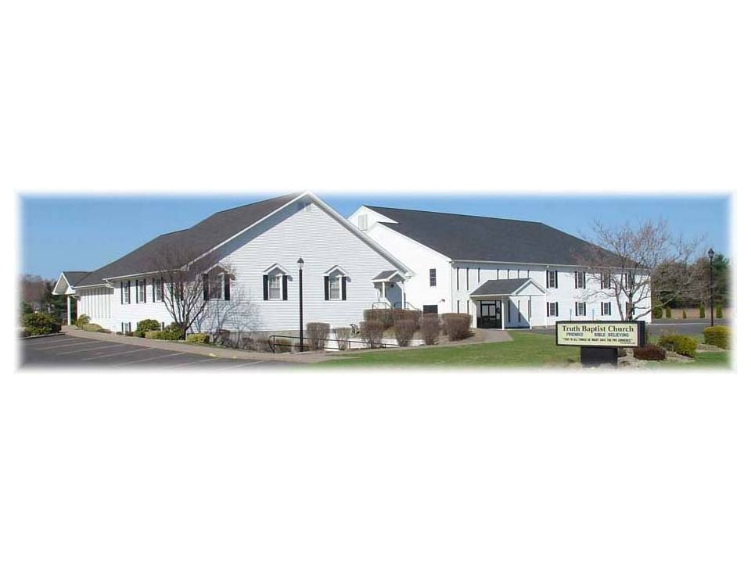
Truth Baptist Church

That in all things He might have the preeminence.
Colossians 1:18

July 31, 2016

