Truth Baptist Church
60 Burnham Street, South Windsor, CT 06074
(860) 289-8976
www.TruthBaptistChurch.org
info@TruthBaptistChurch.org
Bim Rowley – Pastor
Matthew Harper –Associate Pastor
Josh Hummel – Music Director

Schedule for Today
9:00 a.m. Bible Memory
9:15 a.m. Children’s Sunday School
9:15 a.m. Care Group Sunday
10:30 a.m. Morning Service
5:45 p.m. JST Rehearsal
6:00 p.m. Selah Service
7:15 p.m. Chili Cook-off

Schedule for the Week
Tuesday 6:15 p.m. A Taste of Fellowship
Wednesday 7:00 p.m.. Bible Study & Prayer
Kids 4 Truth
Truth Teens
Thursday 6:00 p.m. Truth Basketball League
7:00 p.m. Ladies Bible Study
Saturday 8:30 a.m. Truth Basketball League
Saturday 5:00 p.m. Fondue in February

Titus Women’s Ministry
This is a mentoring ministry for all women in the church. You can sign up to mentor or to be mentored. There is a sign-up list in the lobby. A great opportunity to get to know another lady in the church and grow together in Christ! See Beth Mission for details.

Upcoming Events
Contact the church at info@TruthBaptistChurch.org for info on any of these events.

Today, January 31 – 9:15 to 10:15 a.m., Care Group Sunday
Join us for Care Group Sunday. Reference the bulletin insert for more info or see Skip Mission. A list is posted in the lobby.
Tonight, January 31 – 6:00 p.m., Selah Service & Chili Cook-off
Bring your best bowl of chili! If you don’t want to make chili, bring a salad, cornbread, or dessert to share. Church will provide toppings for chili and beverages.
Prizes will be awarded in the following categories:
- Best Traditional Chili (meat, tomatoes, etc.)
- Best Non-traditional Chili (chicken, turkey)
- Best Vegetarian Chili
- Best Chili ages 15 and under.
Tuesday, February 2 – 6:15 p.m., A Taste of Fellowship
Ladies are invited to meet for dinner this month at TGI Fridays, 209 Hale Rd. in Manchester. Come enjoy an evening out with friends!
Saturday, February 6 – 5:00 p.m., Fondue in February
All Young Adults and Young Marrieds are invited to the Hoovers’ home for fondue, fun and fellowship.
Tuesday, February 9 – 6:30 p.m., DIY Natural Products
Join Katalin as she leads a workshop to “Make & Take” DIY natural products with essential oils.
Friday, February 12 – 7:00 p.m., Cook4Health
Second in Katalin’s healthy cooking series class, Three Squashes. All ladies are invited to join us at her home.
Saturday, February 13 – 7:30 a.m., Men’s Meeting
All men are welcome!
Sunday, February 14 -7:15 p.m., Deacons’ Meeting

Weekly Report
Week of January 24, 2016
Attendance
Sunday School 147
Morning Service 232
Evening Service 164
Thursday 118
Offerings $4,548.98

Deacons
Jim Hoover, Skip Mission, Adam Ploszaj, Ed St. Pierre, Keith Tower,
Kevin Tower

Missionaries
Bollon (Taiwan) Olson (Toronto)
Brackett (Argentina) Parry (Panama)
Cerna (El Salvador) Patton (Suriname)
Champlin (Suriname) Prahl (Wisconsin)
Cherian (India) Smith (Asia)
Conrad (Hong Kong) Stertz (Couriers for Christ)
Hoover (Ethiopia) Teachout (Quebec)
Hutchins (Brazil) Townsley (Terryville)
Hudson (Austria) Tuttle (Georgia)
Keller (Russia)

Missionary updates
Frank Parry asks that we continue to pray for Jay and Hannah Brown, who have taken over the work in Panama. An error in paperwork has resulted in some delays in Jay and Hannah receiving a permanent visa. Please pray that this will be resolved quickly. Hannah is still working on her language study and is also expecting a child. Please pray for this young missionary family as they continue to minister to the people of Panama.

Don Stertz (Baptist Couriers for Christ) asks for prayer regarding the printing of Bibles for the Estonian Campaign in August. The Estonian Bible Society owns the copyright and the Bibles are very expensive. Don, Ken, and Larry are hoping to come to a better financial agreement after meeting with the Society. Currently, it is $33 for a large Bible.

Truth Baptist Church
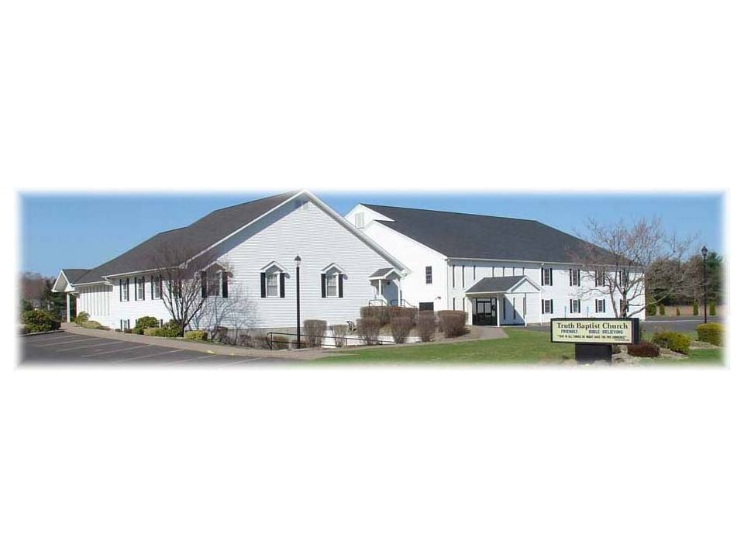
That in all things He might have the preeminence.
Colossians 1:18

January 31, 2016

