Truth Baptist Church
60 Burnham Street, South Windsor, CT 06074
(860) 289-8976
www.TruthBaptistChurch.org
info@truthbaptistchurch.org
Bim Rowley – Pastor
Matthew Harper –Associate Pastor
Josh Hummel – Music Director

Schedule for Today
9:00 a.m. Bible Memory

9:15 a.m. Children’s Sunday School

9:15 a.m. Combined ABF Class

10:30 a.m. Morning Service

6:00 p.m. Evening Service

Schedule for the Week
Monday 6:00 P.M. Ladies Prayer

Tuesday 6:30 P.M. Church Visitation

Wednesday 7:00 P.M. Bible Study & Prayer
Truth Teens
Kids 4 Truth

Christine Greenwood has come for church membership. We will vote on Wednesday, August 19.

Galen & Connie Kulp welcomed their son, Isaiah Joel Kulp, on Wednesday. Mom and baby are doing well!

Upcoming Events
Contact the church at info@TruthBaptistChurch.org for info on any of these events.

July 19 to August 23 – Summer ABF Combined Class
6-week video series on prayer by Philip Yancay. All classes will meet in the auditorium. Jr. and Sr. High classes are also invited.
July 19 to August 30 - For the Life of the World: Letters to the
Exiles
Austin St. Pierre will be presenting a video series in the Young Adult room during the Sunday School hour for the next 7 weeks. Fliers for the class are in the lobby.
August 10 – Ladies Prayer at Cathy Amadasun’s home
All ladies are invited to meet on Monday, August 10, at 6:00 p.m. for a time of prayer. Join us as we pray for the needs of the TBC family.
August 21 & 22 – Church Picnic & Campout
There will be a picnic on Friday evening followed by a
family camp-out. Make plans to join us for lots of fun!
August 23 – Teen Afterglow
This month’s Afterglow will be hosted by the Morrells
here at the church. The Afterglow is open to all teens
and will begin after the evening service.
August 29 – Truth Soccer League
The 2015 season will begin on Saturday, August 29, at 9:00 a.m. with registration and a scrimmage. Registration will be available online in early August. The season will end on October 17 with an exciting tournament and awards ceremony. There is a $25.00 fee for each child. Please see Keith Tower if you are interested in helping in TSL.

Weekly Report
Week of August 2, 2015
Attendance
Sunday School 160
Morning Service 218
Evening Service 166
Wednesday 133
Offerings $6,773.31

Our Missionaries
Brackett (Argentina) Moore (South Africa)
Cerna (El Salvador) Olson (Toronto)
Champlin (Suriname) Parry (Panama)
Cherian (India) Patton (Suriname)
Conrad (Hong Kong) Prahl (Wisconsin)
Hoover (Ethiopia) Smith (Asia)
Hudson (Austria) Stertz (Couriers for Christ)
Hutchins (Brazil) Teachout (Quebec)
Keller (Russia) Townsley (Terryville)
Tuttle (Georgia)

Couriers for Christ is planning a campaign in Tallin, Estonia in August of 2016. Please pray now for their planning.

Ray & Wanda Hoover are in the States on furlough. Please pray for them as they visit family and supporting churches.

Truth Baptist Church
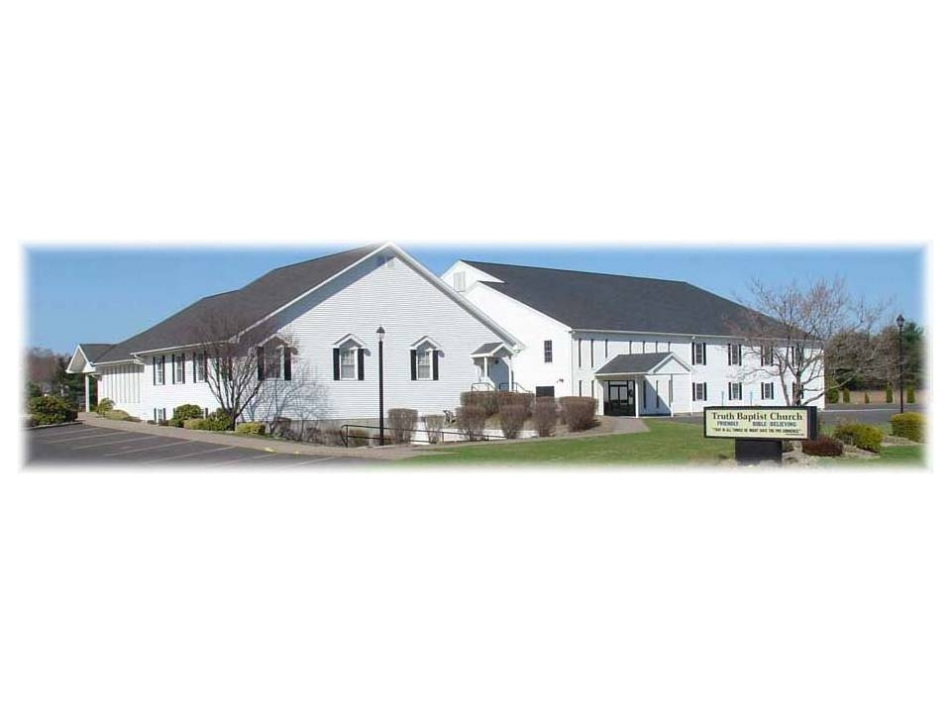
That in all things He might have the preeminence.
Colossians 1:18

August 9, 2015

