A Changed Life Brings Music to the Ears

There are many things in life that are really life-changing, especially when you are my age. You do start to reflect more on the goodness of the Lord, of the many years of past hurdles. I remember the life changing, salvation decision at the age of 19 and then shortly thereafter, the decision to give the Lord my life and all I have. I remember the life-changing experience it was to marry a beautiful, blonde-haired, girl named Beth Cook. All the wonderful ramifications that went with that would be too hard to number.

When I was about 40 years old, I came across a system of Bible reading and prayer that really changed my life as well. At that time, I was a happy husband, a father of two, blue-eyed boys and settled in the most incredible Christian ministry that I never dreamed that I could ever be a part: the Wilds. At that time I did have a devotional and prayer life. You might say that it was a more dutiful time than a relational time. It was also a period of time in my life where I wanted to know the Lord’s heart in the matter of music. There was so much discussion – so much division. Could I really understand the Lord’s heart in an area that was so divisive? I would get up early many times and do my thing and wished that there would be so much more. How I wanted it to be a time where I was truly worshipping and fellowshipping with my Creator, my God. Well, it certainly wasn’t that. I would go for days, knowing that the precious Word was influencing my life – somehow.

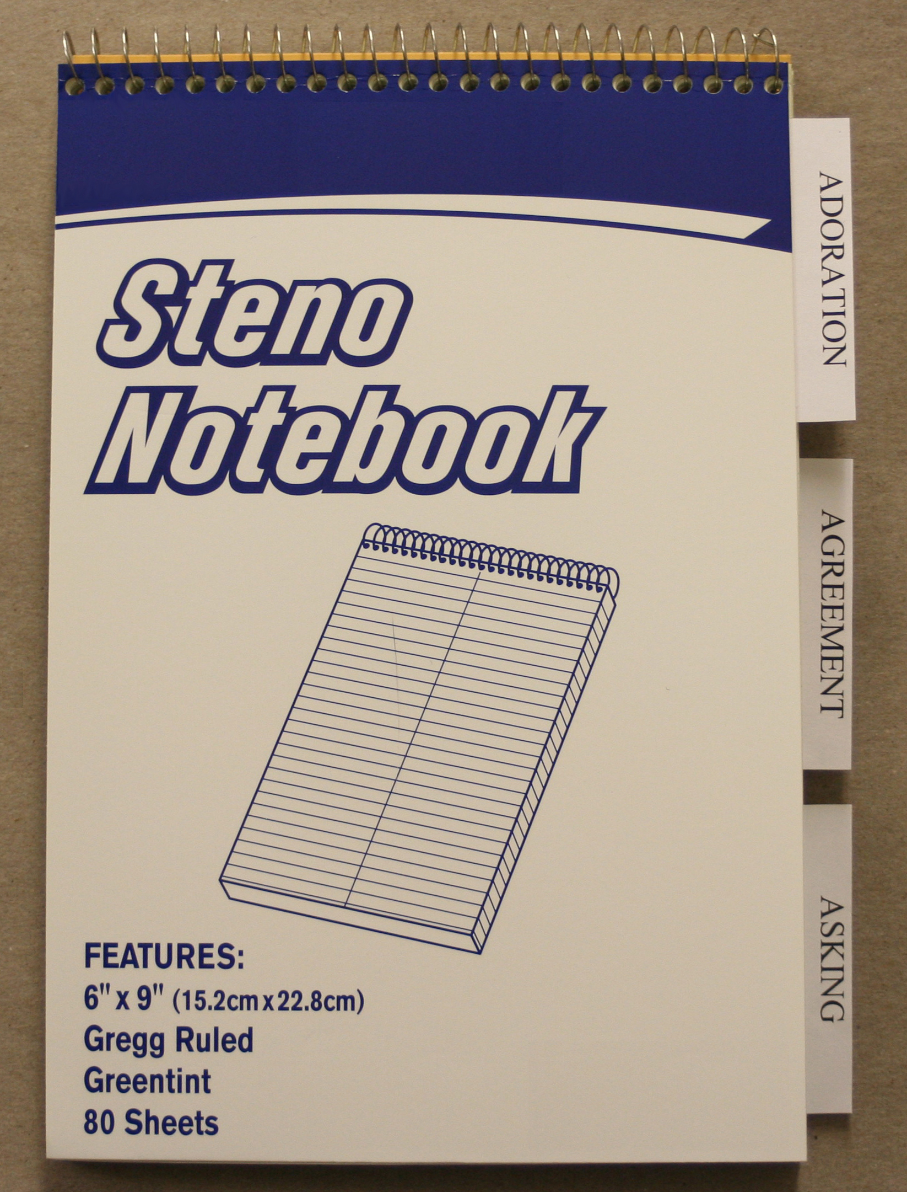
I then came across an amazing combination of information that has been the single, most life-changing experience for many years since. It is a combination of prayer and Bible study information from men like Marty Von, George Mueller, Ken Collier, Jim Berg and oh yes, my favorite preacher, Mark Minnick. Marty Von comes each year to the Wilds to do one of our three CIT Sessions during the summer. Each year he would bring a message on prayer, encouraging the kids to spend just 10 minutes a day in prayer. The prayer would include three sections: Adoration, Agreement, and Asking. I remember thinking how selfish my prayers would be. I would spend most of my time in the Asking area, almost never spending time simply Adoring my God, who He is and what He has done, is doing, or will do for me. About the same time, I was reading how Mueller said that the thing that changed his prayer life [and we all would like to have a prayer life like Mueller’s] was when he started allowing the Word of God to dictate how he would pray. Of course, I never found what that system was.
Figure A
In God’s grace, though, the combination of these two elements became a tool in my life to see God’s sanctifying work in my life.

I secured a steno book and divided it into the three sections: Adoration, Agreement, and Asking. [Figure A] I divided the book in half, placing a divider on the first page [Adoration], then a divider half-way through the book [Agreement] and then one seven pages from the back [Asking]. The Steno book was perfect as it divided each page into two columns because each of the three sections had two sections within them.

Under Adoration, I placed on the left column the word: Praise [applauding God for who He is]; and on the right column I placed the word: Thanksgiving [applauding God for what He has done, is doing, or will do]. [Figure B]


Figure B

I then went to the Agreement page and did the same thing – only I put: Confession of specific sins in the left column, and then on the right: Confession of sin tendencies. [Figure C]


Figure C

Then, going to the Asking section, I placed in the left column: Intercession [asking on behalf of others] and in the right column: Petition [personal requests] one for Daily and one for each day of the week [Monday-Friday]. [Figure D and E]


Figure D


Figure E

Here’s the plan: I’ve always enjoyed reading through the Bible. I’m a layman, and this is something that has really worked for me. I remember starting in the book of Deuteronomy, putting off the weightier sections of Leviticus, etc. As I read, I would find something about my God in the section of what I read – usually one or two chapters. [I ended up reading less each day than I did before, but I would get so much more out of my reading.] I would place characteristics or attributes about my God in the left column: Praise, and then place things in the passage that told of what He had done in the right column: Thanksgiving. I would plan to come back to these things when I would pray. I would also write in my Agreement section specific things from the passage that would deal with my own nature. I was amazed how the power of the Word would specifically confront certain areas of my life that were wrong or needed to change. In the left column, I would actually write down specific sin issues that needed confession; and in the right, I would write down areas in which I was prone to sin. Again, I would plan to come back to this in my prayer time.

After writing down characteristics about my God and the issues concerning my own flesh, I would go to pray. I would praise the Lord specifically for the things that I read about Him that day, and I would thank Him for those things that He has done for me that were written in the passage. I would then go to the Agreement section and confess those sins of mine that I learned about in the passage. Then I would move to the column and confess the sins I would be prone to do and ask Him for victory in those areas. It was a defensive/offensive approach to my sin nature. It allowed me to depend on Him for a strategy that would allow for real growth in the areas that I would so often fall. Adding these two areas to my private worship time allowed me to know who my God is and how wickedly sinful my flesh was.

Then, I would move on to my daily Asking section. Under “Intercession,” I would pray for the top five prickly people in my life – personality conflicts. There are people that don’t like me and then there are people that are hard to like for one reason or another. I pray for these folks. God always changes my attitude toward them when I pray for them each day. In fact, the person who ends up changing the most is me. Finding that I am at least some of the problem is an amazing solution to the conflicts. Continuing under Intercession, I would pray for my closest relationships and their requests. Under Petition, I would pray for my 5 top sins, asking God to help develop a strategy for victory. Then I would add my personal requests that would be dearest to me and petition my Lord.

Finally, I would move to the day and intercede for folk for that day only. Some people would get prayed for once a week, twice a week or three times a week. This allowed me to spread out my prayer list to where I could get it all done. I was able to tell people that I pray for them regularly or tell some that Friday was their day when I prayed for them etc. Then these daily lists would also include my lesser petitions.

There were many things that I noticed that greatly changed me:

- I would remember what I read that morning. Forgetting what I would read on a certain day was always a frustration to me. By lunch, I wouldn’t remember what I had read. With this system, the principles are remembered so much easier – they would be read, written down, and then prayed.

- I would always want to spend more time in the Word and prayer. I remember forcing myself to keep reading and praying to complete a half hour session. Now I get to the end of my time and always wish that I didn’t have to stop. Before it was always dutiful. Now it is so much more fellowship oriented.

- I am able to pray for people on a consistent basis. Forgetting to pray for others and their requests was not a problem of writing the requests down, but of actually getting to their requests and actually praying for them. This spread out the requests in such a way that I could pray consistently for them.

This is not the only way to have a private worship time, but this is “a” way to have them. When asked to write this article, I kept coming back to sharing these principles. It has affected me more than I could ever share with you. In developing a personal philosophy of music, I found hundreds of passages that helped me understand that music was all about God. The things that affected me most musically were not necessarily the passages that dealt specifically with music, but the passages that dealt specifically about the character of my God. May the Lord bless you on your journey through the Scriptures. May we all seek to ask the Lord, like the disciples did: “Lord, teach us to pray,” and may we have the same passion that Paul had: “O, that I may know Thee.”

